1 Variable:

Habitat Loss

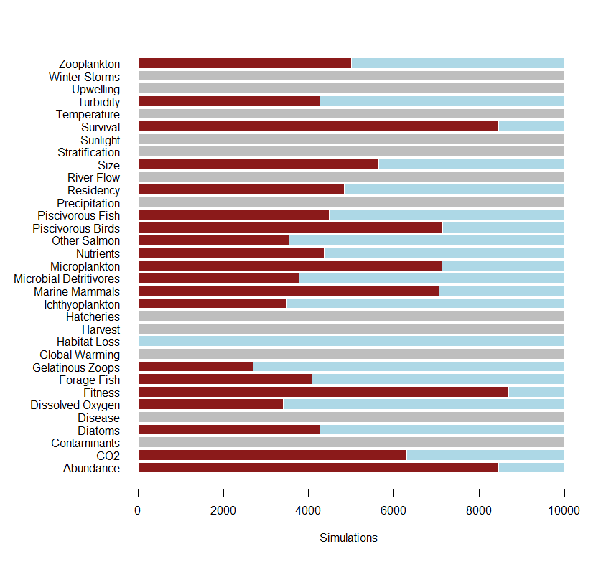

2 Variables:

Habitat Loss, Zooplankton

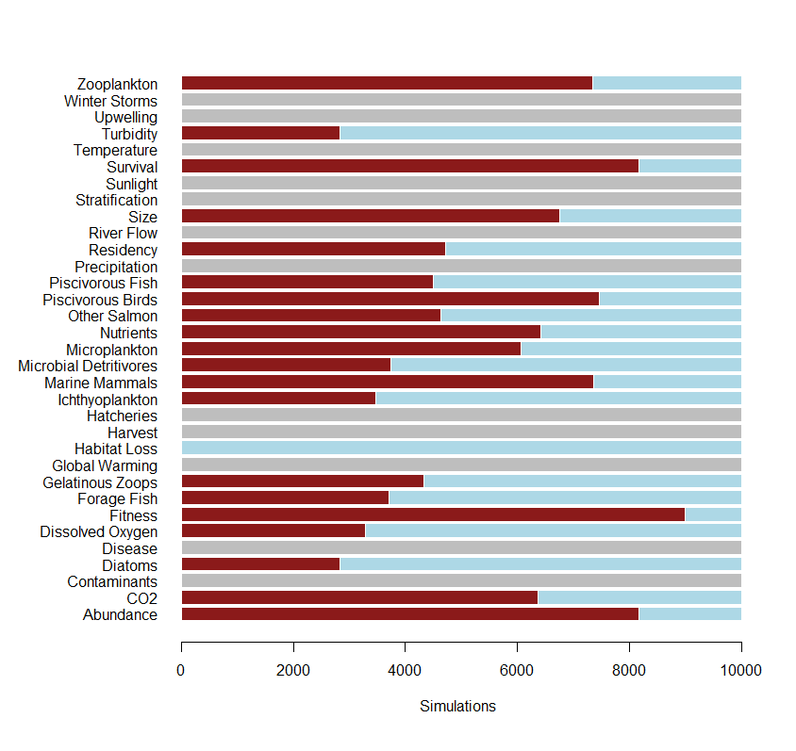

3 Variables:

Habitat Loss, Zooplankton, Temperature

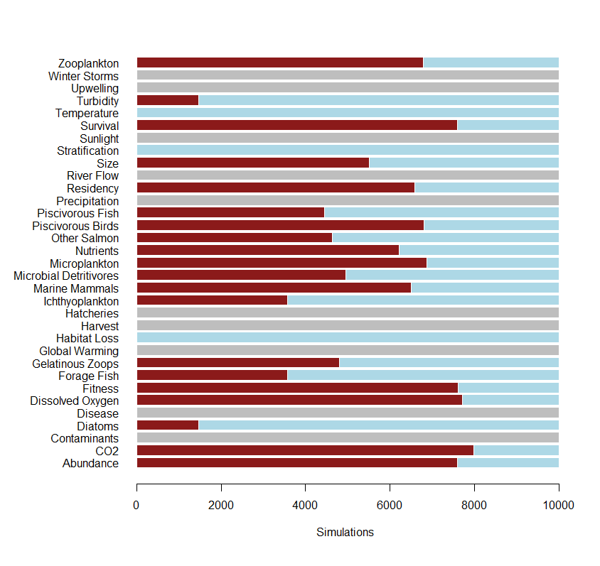

4 Variables:

Habitat Loss, Zooplankton, Temperature, Disease

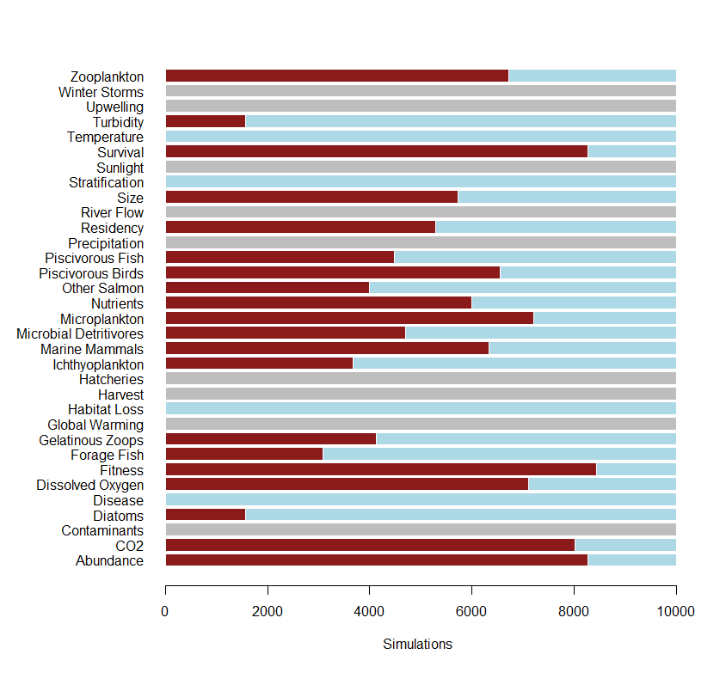

5 Variables:

Habitat Loss, Zooplankton, Temperature, Disease, Marine Mammals

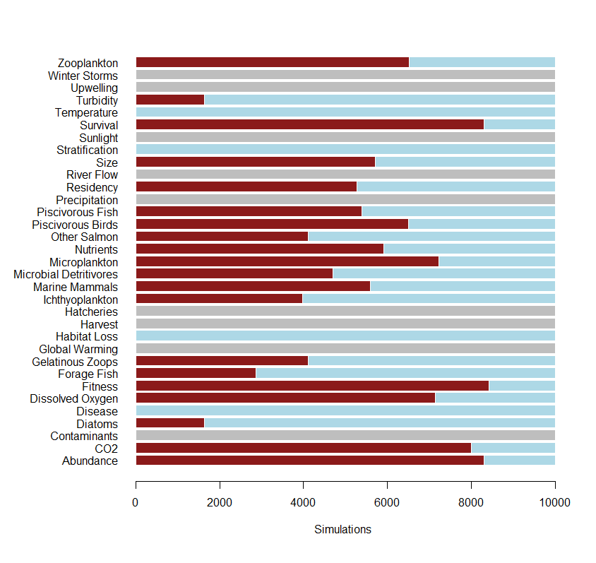

6 Variables:

Habitat Loss, Zooplankton, Temperature, Disease, Marine Mammals, Diatoms

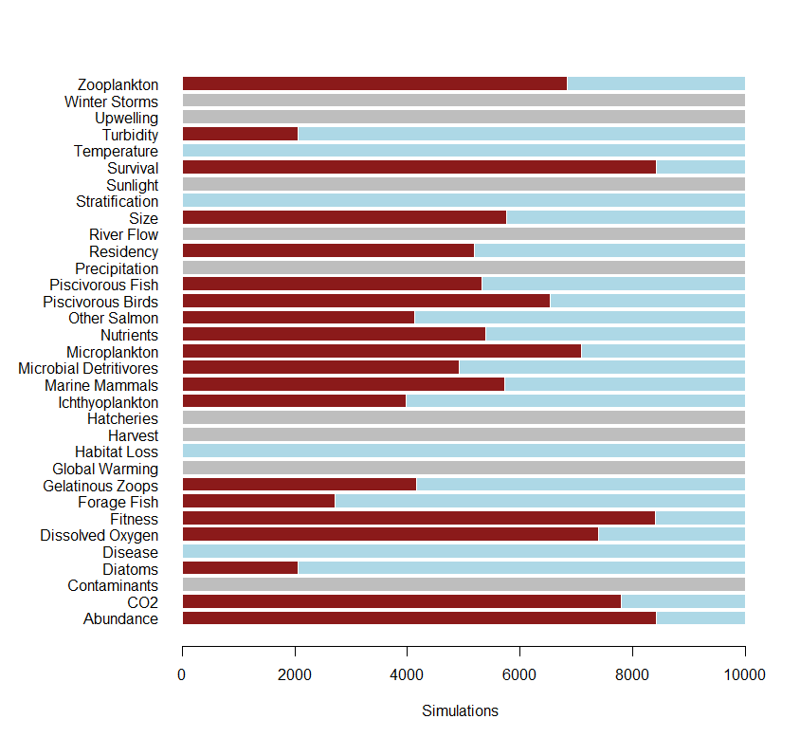

7 Variables:

Habitat Loss, Zooplankton, Temperature, Disease, Marine Mammals, Diatoms, CO2

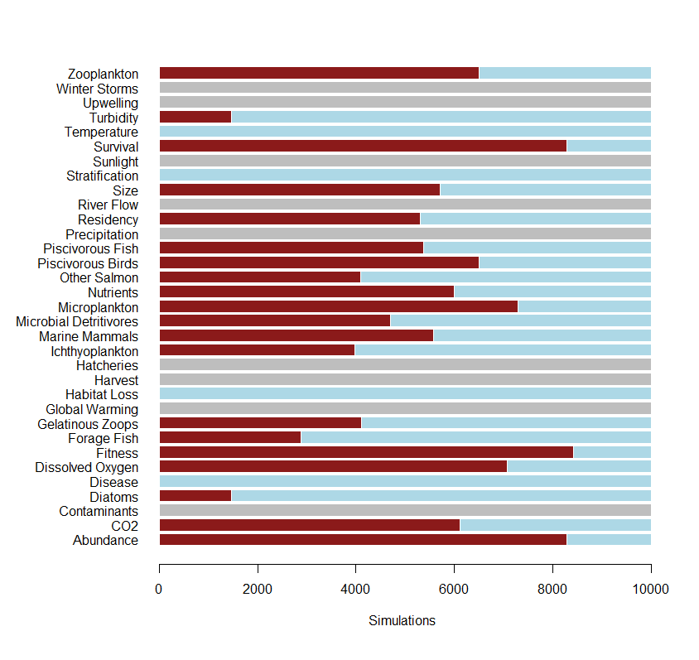

8 Variables:

Habitat Loss, Zooplankton, Temperature, Disease, Marine Mammals, Diatoms, CO2, Gelatinous Zooplankton

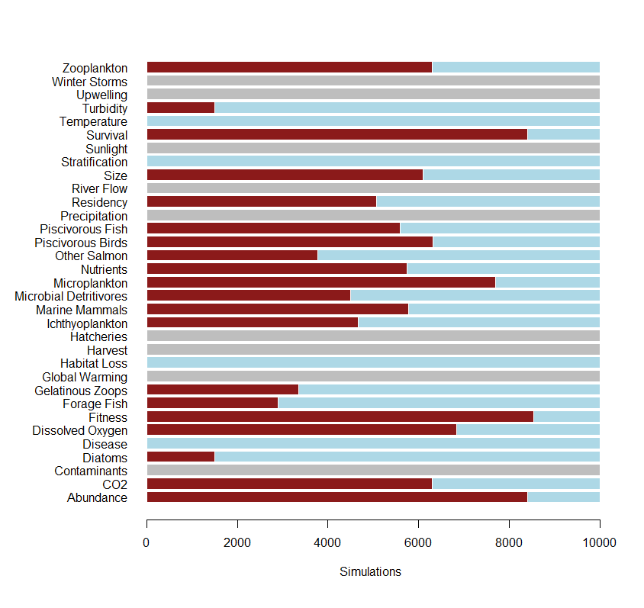

9 Variables

Habitat Loss, Zooplankton, Temperature, Disease, Marine Mammals, Diatoms, CO2, Gelatinous Zooplankton, Nutrients



10 Variables

Habitat Loss, Zooplankton, Temperature, Disease, Marine Mammals, Diatoms, CO2, Gelatinous Zooplankton, Nutrients, Hatcheries

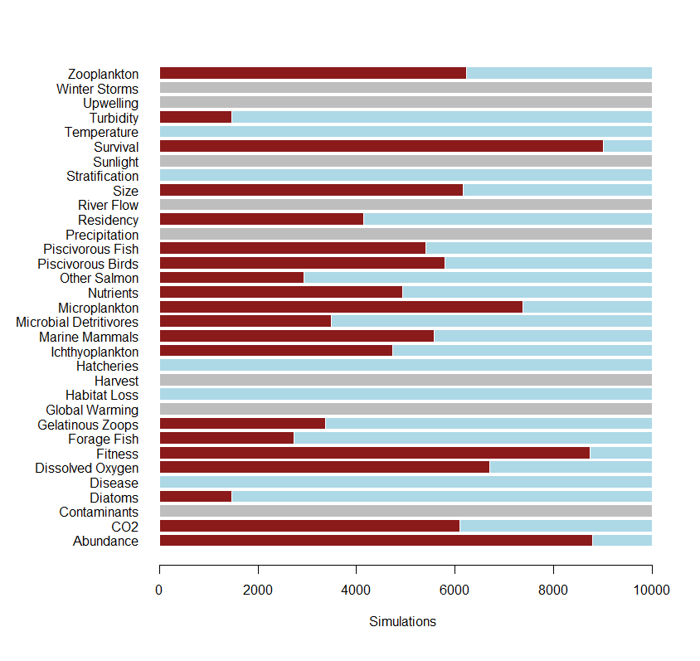

10 Weakly Connected Vars.

Global Warming, Ichthyoplankton, Marine Mammals, Microbial Detritivores, Nutrients, Pisc. Birds, Precipitation, Stratification, Sunlight, Zooplankton

